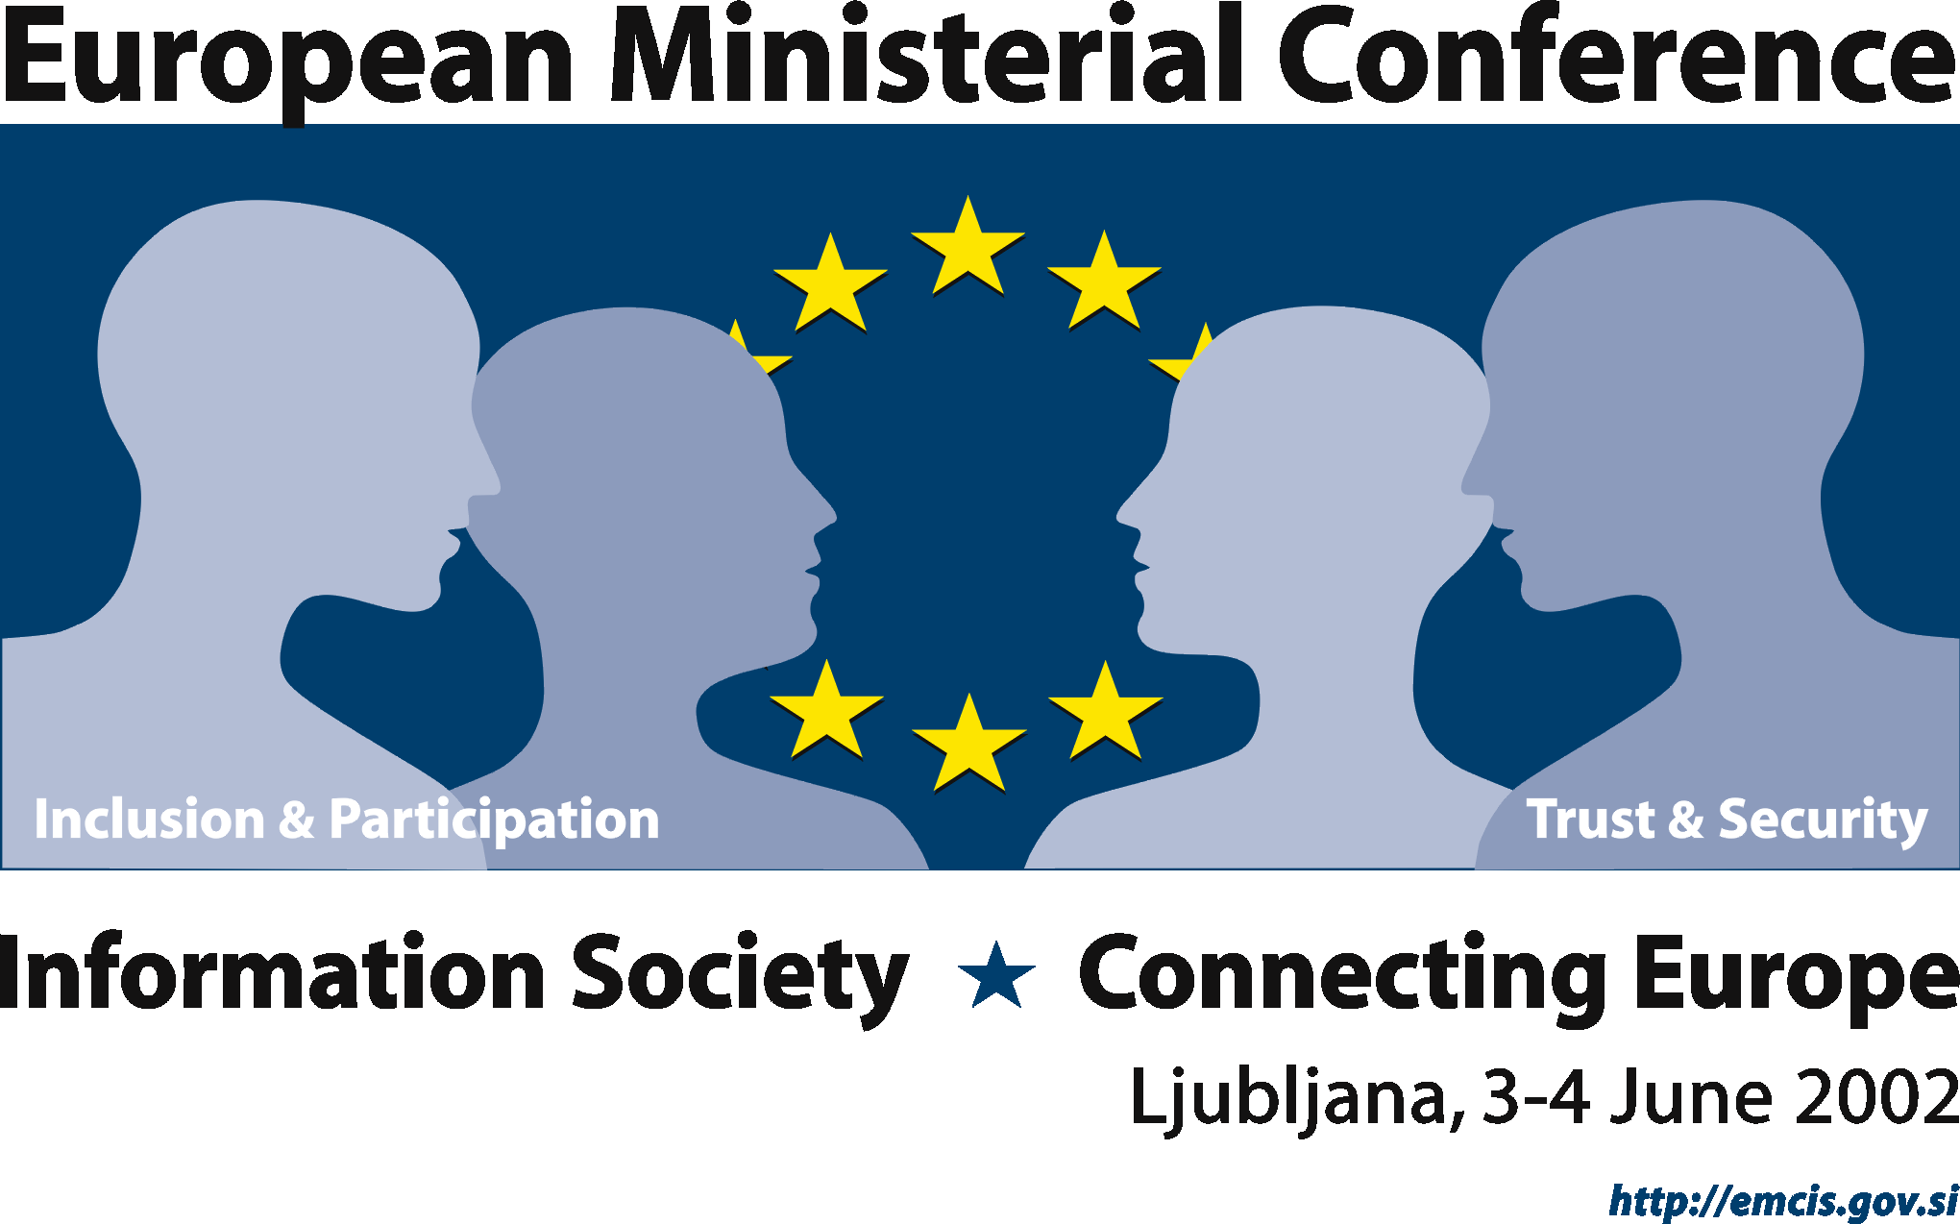 | 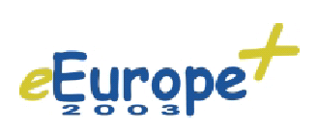

Venue

Miklošičeva 1, 1000 Ljubljana

PERSONAL DETAILS (Please use capital letters)

Family Name:
First Name(s):
Mr |  | Mrs |  |  | Function:
Organisation:
Address:
Postal Code: |  |  |  |  |  |  | City:
Country:
E-mail:
Tel: |  |  |  |  |  |  |  | Fax:

Thematic sessions

I will attend the following thematic session(s):

3–4 June 2002 | 1 |  | Knowledge Based Society and Economy
 | 2 |  | Information Infrastructure
 | 3 |  | Emerging Services at Municipalities Level – An Initiative for All

Categories of Participants

Select the category and institution please.
Category: |  | Institution:
 | Head of Delegation |  | Government
 | Member of Delegation |  | Local Authority
 | Participant |  | Industry
 | Exhibitor |  | Civil society
 | EU staff |  | Academic/scientific
 | Slovenian staff |  | Other organisations

Travel & Hotel

Please see the Hotel booking form.

Date: |  | Signature:

Please complete this form in capital letters and return it by fax or email
by April 30, 2002.
Fax: +386 1 478-83-75, Email: emcis.mid@gov.si, URL: http://emcis.gov.si
One form only per participant, please.

